**QUESTION#1**

Implement the following scenario in C++:

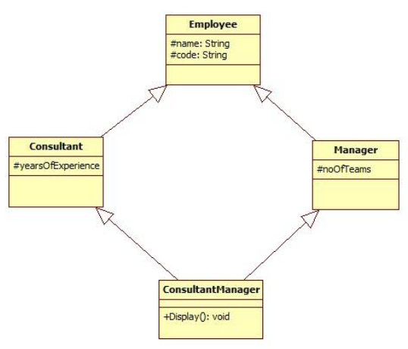

1. No accessors and mutators are allowed to be used.
2. The Display() function in “ConsultantManager” should be capable of displaying the values of all the data members declared in the scenario (name,code,yearsOfExperience,noOfTeams) without being able to alter the values.
3. The “int main()” function should contain only three program statements which are as follows:
4. In the first statement, create object of “ConsultantManager” and pass the values for all the data members:

**ConsultantManager obj("Ali",”S-123”,17,5);**

1. In the second statement, call the Display() function.
2. In the third statement, return 0.

**Question # 02:**

Implement the following scenario in C++:



1. The interestaccount class adds interest for every deposit,assume a default of 30%.
2. The charging account class charges a default fee of $3 for every withdrawl.
3. Transfer method of aci class takes two parameters,amount to be transfer and object of class in which we have to transfer that amount.
4. Make parametrized constructor, and default constructor to take user input for all data members.
5. Make a driver program to test all functionalities.